**ASSIGNMENT-2**

**Name:** Kanthimathinathan A

**Reg No:** 953619104020

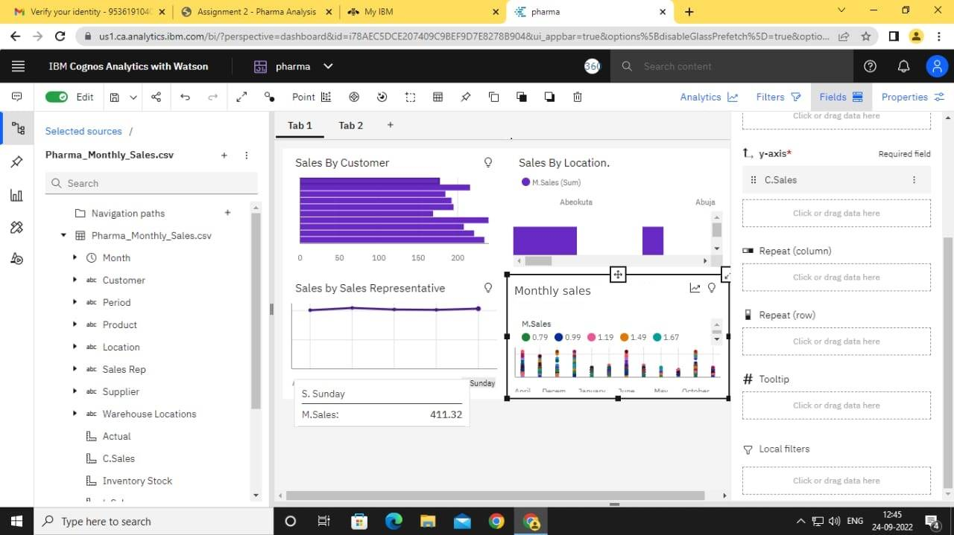

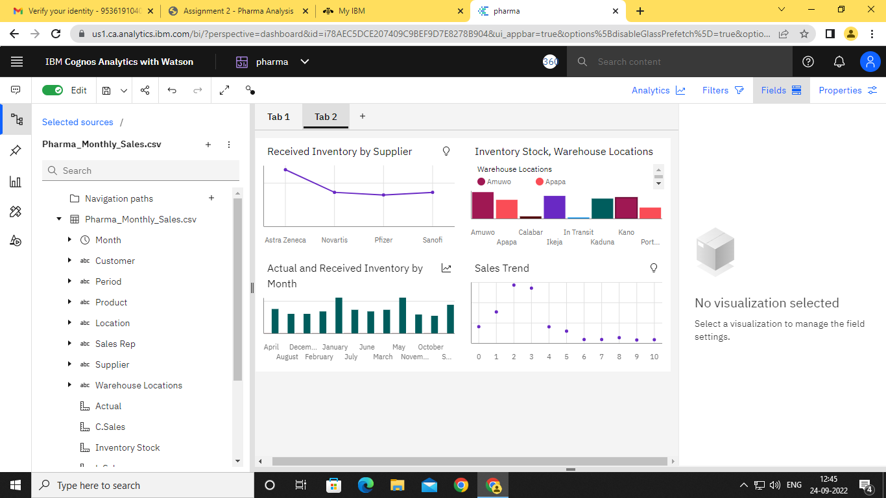

Link:

<https://us1.ca.analytics.ibm.com/bi/?perspective=dashboard&pathRef=.my_folders%2Fpharma&action=view&mode=dashboard&subView=model000001836e48bd42_00000000>